**Angular Directives**

##### **What are Angular Directives?**

The Angular Directives are the elements which are basically used to change the behavior or appearance or layout of the DOM (Document Object Model) element. In other words, we can say that the directives are basically used to extend the power of HTML attributes and to change the appearance or behavior of a DOM element.

##### **Types of Directives in Angular:**

The Directives are classified into three types based on their behavior. Please have a look at the following image for a better understanding of the directives classification.

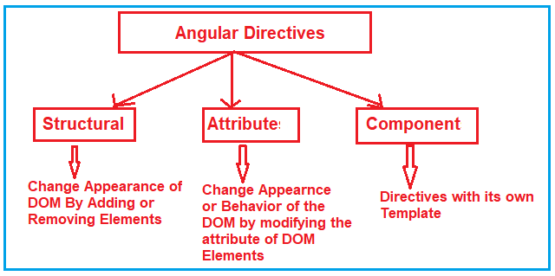

As you can see in the above image, the directives in angular are classified into three types. They are as follows:

1. **Structural Directive**
2. **Attribute Directive**
3. **Component Directives**

Let us discuss each of these directives in detail.

##### **Structural Directives:**

The Structural Directives are responsible for the HTML layout. That means, they will shape or reshape the HTML view by simply adding or removing the elements from the DOM. These directives are basically used to handle how the component or the element should render in a template.

In Angular, there are three structural directives are available. They are as follows:

1. **NgFor (*ngFor)**
2. **NgIf (*ngIf)**
3. **NgSwitch (*ngSwitch)**

##### **Attribute Directives:**

Attribute Directives are basically used to modify the behavior or appearance of the DOM element or the Component. In Angular, there are two in-built attribute directives available. They are as follows:

1. **NgStyle**: This NgStyle Attribute Directive is basically used to modify the element appearance or behavior.
2. **NgClass**: This NgClass Attribute Directive is basically used to change the class attribute of the element in the DOM or in the Component to which it has been attached.

We will discuss these two built-in attributes in detail in our upcoming articles.

##### **Component Directives:**

We have already discussed Component in our previous articles. The Component is also a type of directive in angular with its own template, styles, and logic needed for the view. The Component Directive is the most widely used directive in the angular application and you cannot create an angular application without a component.

A component directive requires a view along with its attached behavior and this type of directive adds DOM Elements. The Component Directive is a class with **@Component** decorator function.

The naming convention for components is **name.component.ts**. For example, if you want to create a component with the name student then it should be student.component.ts.

## ****Angular ngFor Directive with Examples****

##### **What is Angular ngFor Directive?**

The built-in ngFor directive belongs to the Structural directive category. As it belongs to the structural directive category, it is used to change the structure of the DOM.

The ngFor directive is very much similar to the “for loop” used in most of the programming languages. So, the NgFor directive is used to iterate over a collection of data. The syntax to use ngFor directive is: **\*ngFor=”let <value> of <collection>”**

Here, <value> is a variable name and collection is a property on your component which a collection of data. Usually an array but it can be anything that can be iterated over in a for loop.

##### **Understanding Angular ngFor Directive:**

Let us understand the ngFor structural directive in angular application with an example. We are going to use the following array of Student objects in this demo.

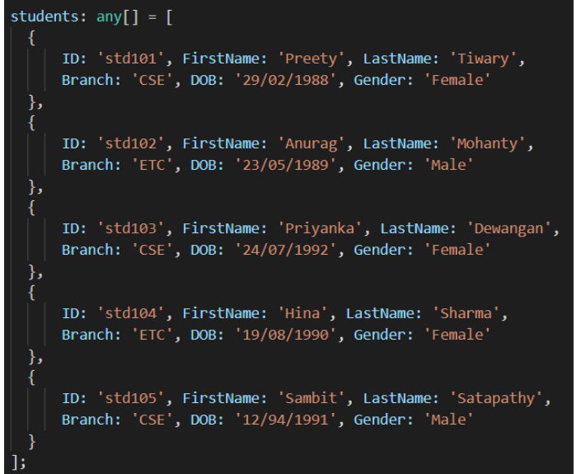

Then we want to display the above students in a table on a web page as shown below.

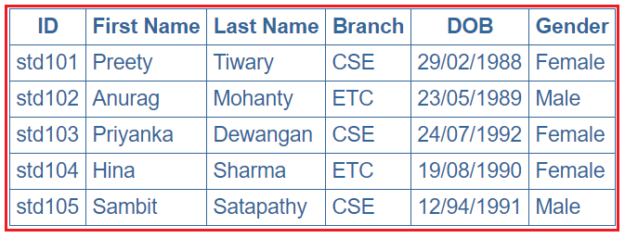

Let’s discuss the Step By Step Procedure to achieve the above output using Angular ngFor Directive:

##### **Step1: Modify the app.component.ts file**

Open **app.component.ts** file and then copy and paste the following code in it. You can find this file within the app folder of your angular project.

**import** **{** Component **}** from '@angular/core';

@Component**({**

selector: 'app-root',

templateUrl: './app.component.html',

styleUrls: **[**'./app.component.css'**]**

**})**

**export** **class** AppComponent **{**

students: **any[]** = **[**

**{**

ID: 'std101', FirstName: 'Preety', LastName: 'Tiwary',

Branch: 'CSE', DOB: '29/02/1988', Gender: 'Female'

**}**,

**{**

ID: 'std102', FirstName: 'Anurag', LastName: 'Mohanty',

Branch: 'ETC', DOB: '23/05/1989', Gender: 'Male'

**}**,

**{**

ID: 'std103', FirstName: 'Priyanka', LastName: 'Dewangan',

Branch: 'CSE', DOB: '24/07/1992', Gender: 'Female'

**}**,

**{**

ID: 'std104', FirstName: 'Hina', LastName: 'Sharma',

Branch: 'ETC', DOB: '19/08/1990', Gender: 'Female'

**}**,

**{**

ID: 'std105', FirstName: 'Sambit', LastName: 'Satapathy',

Branch: 'CSE', DOB: '12/94/1991', Gender: 'Male'

**}**

**]**;

**}**

As you can see in the above code, we have created one array (i.e. students) which a collection of student data. Again we have specified the templateUrl and StyleUrls, so, let proceed and modifies these two files.

##### **Step2: Modify app.component.css file**

Open **app.component.css** file and then copy and paste the following code in it. You can find this file within your app folder. The following styles are going to be used in our HTML page to style table data.

table **{**

color: *#369*;

font-family: Arial, Helvetica, sans-serif;

font-size: large;

border-collapse: collapse;

**}**

td **{**

border: 1px solid *#369*;

padding:5px;

**}**

th**{**

border: 1px solid *#369*;

padding:5px;

**}**

##### **Step3: Modify app.component.html file**

Open **app.component.html** file and then copy and paste the following code in it. You can also find this file within your app folder.

**<table>**

**<thead>**

**<tr>**

**<th>**ID**</th>**

**<th>**First Name**</th>**

**<th>**Last Name**</th>**

**<th>**Branch**</th>**

**<th>**DOB**</th>**

**<th>**Gender**</th>**

**</tr>**

**</thead>**

**<tbody>**

**<tr** *ngFor='let student of students'**>**

**<td>**{{student.ID}}**</td>**

**<td>**{{student.FirstName}}**</td>**

**<td>**{{student.LastName}}**</td>**

**<td>**{{student.Branch}}**</td>**

**<td>**{{student.DOB}}**</td>**

**<td>**{{student.Gender}}**</td>**

**</tr>**

**<tr** *ngIf="!students || students.length==0"**>**

**<td** colspan="7"**>**

No Students to display

**</td>**

**</tr>**

**</tbody>**

**</table>**

##### **Understand the above Code:**

1. Here, the **ngFor**directive is used to iterate over a collection. In this example, the collection is an array of students.
2. As the **ngFor**directive is a structural directive, so it is prefixed with **\* (star)**. So, the point that you need to remember is, all the structural directive are prefixed with a *.
3. **\*ngFor=’let student of students’** – In this statement, the ‘**student**‘ is called template input variable, which can be accessed by the <tr> element and any of its child elements.
4. The **ngIf**structural directive displays the row “**No Students to display**” when the student’s property does not exist or when there are no students in the array.

##### **Step4: Modify app.module.ts file**

Open **app.module.ts** file which is present inside the app folder and then copy and paste the following code.

**import** **{** BrowserModule **}** from '@angular/platform-browser';

**import** **{** NgModule **}** from '@angular/core';

**import** **{** AppRoutingModule **}** from './app-routing.module';

**import** **{** AppComponent **}** from './app.component';

**import** **{** FormsModule **}** from '@angular/forms';

@NgModule**({**

declarations: **[**

AppComponent

**]**,

imports: **[**

BrowserModule,

AppRoutingModule,

FormsModule

**]**,

providers: **[]**,

bootstrap: **[**AppComponent**]**

**})**

**export** **class** AppModule **{** **}**

That’s it. We have done with our implementation. Now run the application and you will notice that the students are displayed in the table as expected.

##### **ngFor – Local Variables:**

The ngFor structural directive has the following local variable which you can use to customize the data.

1. **Index**: This variable is used to provide the index position of the current element while iteration.
2. **First**: It returns boolean true if the current element is the first element in the iteration else it will return false.
3. **Last**: It returns boolean true if the current element is the last element in the iteration else it will return false.
4. **Even**: It returns boolean true if the current element is even element based on the index position in the iteration else it will return false.
5. **Odd**: It returns boolean true if the current element is an odd element based on the index position in the iteration else it will return false.

Let us understand the above ngFor local variables one by one with example.

##### **How to get the index of an item in a collection in an angular application?**

We can get the index of an item in a collection using the index property of the ngFor directive. Let us understand this with an example. What we want to do here is, along with the student data, we also want to display the index position as shown in the below image.

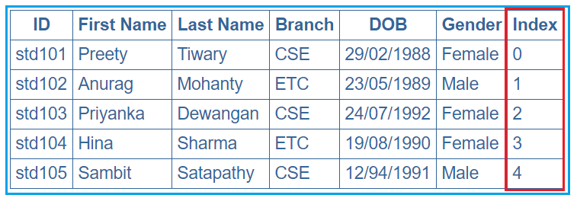

In order to achieve this, we want to use the ngFor local variable index. So, modify the app.component.html as shown below.

**<table>**

**<thead>**

**<tr>**

**<th>**ID**</th>**

**<th>**First Name**</th>**

**<th>**Last Name**</th>**

**<th>**Branch**</th>**

**<th>**DOB**</th>**

**<th>**Gender**</th>**

**<th>**Index**</th>**

**</tr>**

**</thead>**

**<tbody>**

**<tr** *ngFor='let student of students; let i=index'**>**

**<td>**{{student.ID}}**</td>**

**<td>**{{student.FirstName}}**</td>**

**<td>**{{student.LastName}}**</td>**

**<td>**{{student.Branch}}**</td>**

**<td>**{{student.DOB}}**</td>**

**<td>**{{student.Gender}}**</td>**

**<td>**{{i}}**</td>**

**</tr>**

**</tbody>**

**</table>**

Notice that in the above code, we are using the index property of the Angular ngFor directive to store the index position of an element in a template input variable “i”. The variable “i” is then used in the <td> element where we want to display the index value. We used the let keyword to create the template input variable “i”.  The let keyword in angular is very much similar to the var keyword.

The index of an element is extremely useful when you are creating the HTML elements dynamically.

##### **How to identify the first and the last elements in a collection in an angular application?**

To identify the First and Last elements in a collection, you need to use the first and last properties of the ngFor directive respectively. Let us understand this with an example. We want to display the student data along with whether that student is the first or the last student as shown in the below image.

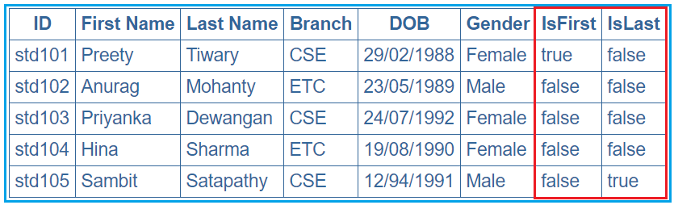

In order to achieve this, modify the **app.component.html** file as shown below.

**<table>**

**<thead>**

**<tr>**

**<th>**ID**</th>**

**<th>**First Name**</th>**

**<th>**Last Name**</th>**

**<th>**Branch**</th>**

**<th>**DOB**</th>**

**<th>**Gender**</th>**

**<th>**IsFirst**</th>**

**<th>**IsLast**</th>**

**</tr>**

**</thead>**

**<tbody>**

**<tr** *ngFor='let student of students; let isFirst = first; let isLast = last'**>**

**<td>**{{student.ID}}**</td>**

**<td>**{{student.FirstName}}**</td>**

**<td>**{{student.LastName}}**</td>**

**<td>**{{student.Branch}}**</td>**

**<td>**{{student.DOB}}**</td>**

**<td>**{{student.Gender}}**</td>**

**<td>**{{isFirst}}**</td>**

**<td>**{{isLast}}**</td>**

**</tr>**

**</tbody>**

**</table>**

##### **How to identify the even and odd elements in a collection in an angular application?**

In order to identify the Event and Odd elements in a collection in angular, you need to use the even and odd local variable of the ngFor directive respectively. Let us understand this with an example. We want to display the student data along with whether that student is odd or even as shown in the below image.

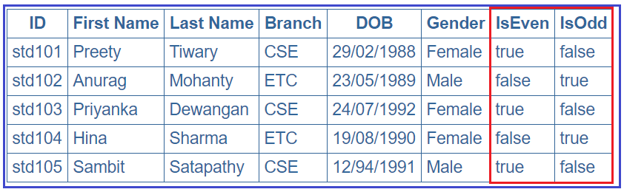

In order to achieve this, modify the **app.component.html** file as shown below.

**<table>**

**<thead>**

**<tr>**

**<th>**ID**</th>**

**<th>**First Name**</th>**

**<th>**Last Name**</th>**

**<th>**Branch**</th>**

**<th>**DOB**</th>**

**<th>**Gender**</th>**

**<th>**IsEven**</th>**

**<th>**IsOdd**</th>**

**</tr>**

**</thead>**

**<tbody>**

**<tr** *ngFor='let student of students; let isEven = even; let isOdd = odd'**>**

**<td>**{{student.ID}}**</td>**

**<td>**{{student.FirstName}}**</td>**

**<td>**{{student.LastName}}**</td>**

**<td>**{{student.Branch}}**</td>**

**<td>**{{student.DOB}}**</td>**

**<td>**{{student.Gender}}**</td>**

**<td>**{{isEven}}**</td>**

**<td>**{{isOdd}}**</td>**

**</tr>**

**</tbody>**

**</table>**

## ****Angular ngFor trackBy with Examples****

**Why do we need the Angular ngFor trackBy?**

The use of trackBy is to improve the performance of the angular application. It is usually not needed by default but needed only when your application running into performance issues.

The Angular ngFor directive may perform poorly with the large collections.  A small change to the collection such as adding a new item or removing an existing item from the collection may trigger a cascade of DOM manipulations.

Suppose,

we are storing these data into some kind of collection like an array and then we need to update these data over the webpage using ngFor directive. By default, what angular framework will do is, it will remove all the DOM elements that are associated with the data and will create them again in the DOM tree even if the same data is coming. That means a lot of DOM Manipulation will happen in the background if a large amount of data coming from the API again and again.

##### **Example to understand ngFor trackBy in Angular Application:**

Let us understand the need for angular ngFor trackBy with an example step by step.

##### **Step1: Modify app.component.ts file as shown below.**

Open app.component.ts file and then copy and paste the following in it. As you can see in the below code, the constructor of the AppComponent class initializes the student’s collection property with 3 students’ objects. On the other hand, the **getStudents()** method of the AppComponent class update the same student’s collection property with 5 student objects (the 3 existing students plus another two new student object).

**import** **{** Component **}** from '@angular/core';

@Component**({**

selector: 'app-root',

templateUrl: './app.component.html',

styleUrls: **[**'./app.component.css'**]**

**})**

**export** **class** AppComponent **{**

students: **any[]**;

**constructor()** **{**

this.students = **[**

**{**

ID: 'std101', FirstName: 'Santosh', LastName: 'Jena', Branch: 'CSE',

DOB: '29/02/1988', Gender: 'Male'

**}**,

**{**

ID: 'std102', FirstName: 'Anurag', LastName: 'Mohanty', Branch: 'ETC',

DOB: '23/05/1989', Gender: 'Male'

**}**,

**{**

ID: 'std103', FirstName: 'Priyanka', LastName: 'Dewangan', Branch: 'CSE',

DOB: '24/07/1992', Gender: 'Female'

**}**,

**]**;

**}**

getStudents**()**: **void** **{**

this.students = **[**

**{**

ID: 'std101', FirstName: 'Santosh', LastName: 'Jena', Branch: 'CSE',

DOB: '29/02/1988', Gender: 'Male'

**}**,

**{**

ID: 'std102', FirstName: 'Anurag', LastName: 'Mohanty', Branch: 'ETC',

DOB: '23/05/1989', Gender: 'Male'

**}**,

**{**

ID: 'std103', FirstName: 'Priyanka', LastName: 'Dewangan', Branch: 'CSE',

DOB: '24/07/1992', Gender: 'Female'

**}**,

**{**

ID: 'std104', FirstName: 'Hina', LastName: 'Sharma', Branch: 'ETC',

DOB: '19/08/1990', Gender: 'Female'

**}**,

**{**

ID: 'std105', FirstName: 'Sambit', LastName: 'Satapathy', Branch: 'CSE',

DOB: '12/94/1991', Gender: 'Male'

**}**

**]**;

**}**

**}**

##### **Step2: Modify the app.component.css file**

We are going to use some styles in our HTML page. So, open **app.component.css** file and then copy and paste the following code in it.

table **{**

color: *#369*;

font-family: Arial, Helvetica, sans-serif;

font-size: large;

border-collapse: collapse;

**}**

td **{**

border: 1px solid *#369*;

padding:5px;

**}**

th**{**

border: 1px solid *#369*;

padding:5px;

**}**

##### **Step3: Modify app.module.ts file**

Open your root module i.e. **app.module.ts** file and then copy and paste the following code in it.

**import** **{** BrowserModule **}** from '@angular/platform-browser';

**import** **{** NgModule **}** from '@angular/core';

**import** **{** AppRoutingModule **}** from './app-routing.module';

**import** **{** AppComponent **}** from './app.component';

**import** **{** FormsModule **}** from '@angular/forms';

@NgModule**({**

declarations: **[**

AppComponent

**]**,

imports: **[**

BrowserModule,

AppRoutingModule,

FormsModule

**]**,

providers: **[]**,

bootstrap: **[**AppComponent**]**

**})**

**export** **class** AppModule **{** **}**

##### **Step4: Modify app.component.html file**

Open **app.component.html** file and then copy and paste the following code in it.

**<table>**

**<thead>**

**<tr>**

**<th>**ID**</th>**

**<th>**First Name**</th>**

**<th>**Last Name**</th>**

**<th>**Branch**</th>**

**<th>**DOB**</th>**

**<th>**Gender**</th>**

**</tr>**

**</thead>**

**<tbody>**

**<tr** *ngFor='let student of students'**>**

**<td>**{{student.ID}}**</td>**

**<td>**{{student.FirstName}}**</td>**

**<td>**{{student.LastName}}**</td>**

**<td>**{{student.Branch}}**</td>**

**<td>**{{student.DOB}}**</td>**

**<td>**{{student.Gender}}**</td>**

**</tr>**

**</tbody>**

**</table>**

**<br** **/>**

**<button** (click)='getStudents()'**>**Refresh Students**</button>**

In the above HTML, at the moment we are not using the **trackBy** with **ngFor** directive. So when the page loads for the first time you will see 3 students which are initialized through the constructor of the AppComponent class and when you click on the “**Refresh Students**” button, then you will see the 4th and 5th students as well as shown in the below image.

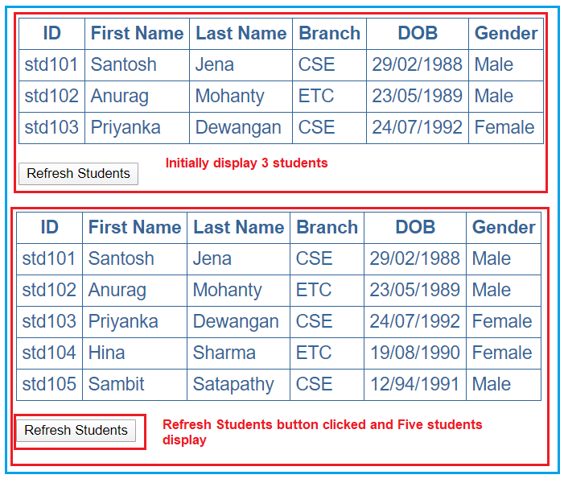

Now you may think that it just added the additional rows for the 4th and 5th students but that’s not true. It internally destroyed all the <tr> and <td> elements of all the students and then recreated them. To confirm this launch the browser developer tools by pressing the F12 key. Then click on the “Elements” tab and expand the <table> and then <tbody> elements.

At this point click on the “**Refresh Students**” button and you will notice that all the <tr> elements are briefly highlighted indicating that they are destroyed and recreated as shown in the below image.

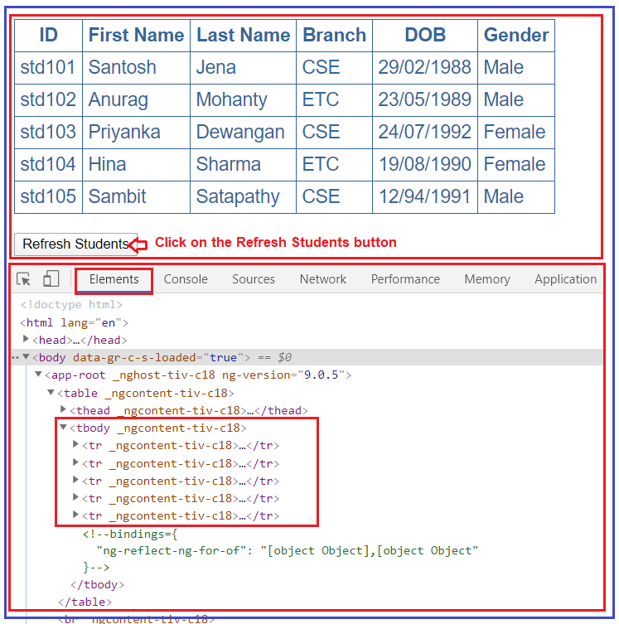

This is because Angular Framework by default keeps track of the objects using the object references. So, when you click on the **“Refresh Students”** button, it will get different object references and as a result, Angular has no other choices but to delete all the old DOM elements and insert the new DOM elements. Image what could happen if the data size is huge.

##### **How to solve the above problem?**

In order to solve the above performance issue problem, the angular framework provides one function called trackBy which will help us to track the items which have been added or removed. The trackBy function will take two arguments, first is the index and the second one is the current item and it will return one unique identifier as return a value using which we can track that item. In our example, we are going to track by Student ID as the student id is unique for each student.

In order to use trackBy, add the following method in the app.component.ts file.

**trackByStudentID(index: number, student: any): string {**  
**return student.ID;**  
**}**

Then do the following changes in the **app.component.html** file:

**<tr *ngFor=’let student of students; trackBy:trackByStudentID’>**

Here we are using the trackBy along with ngFor directive. At this point, run the application and then launch the browser developer tools by pressing the F12 key. When you click on the **“Refresh Students”** button for the first time, then you can notice that only the 4th and 5th rows of the students are highlighted indicating that only those <tr> elements are added.

On the subsequent clicks, nothing is highlighted meaning none of the <tr> elements are destroyed or added as the students’ collection has not changed. Each and every time when you click on the **“Refresh Students”** button you get different object references, but as the Angular is now tracking the student objects using the Student Id instead of object references, as a result, the respective DOM elements are not affected.